Presentations of Results
Bayesian Ridge, K-Nearest Neighbors and 1D CNN
In the modeling phase, three algorithms (Bayesian Ridge, K-Nearest Neighbors (KNN), and 1D Convolutional Neural Network (CNN)) were tested to estimate their performance in cryptocurrency price prediction. Bayesian Ridge model was selected because it can be used to accomplish regression tasks, where a probabilistic manner of estimating the coefficients in a linear regression model is considered. It is effective against multicollinearity and aids in regularizing the information. An algorithm called K-Nearest Neighbors (KNN) was used due to its simplicity and its use in classification and regression. It makes predictions at the basis of a distance to the closest data points in the feature space. Finally, the deep learning model employed was the 1D Convolutional Neural Network (CNN), which has the capability to identify complicated patterns in time-series data. The 1D CNN is good at automatically extracting data features, which is why it is extremely appropriate in forecasting the price changes in cryptocurrencies.
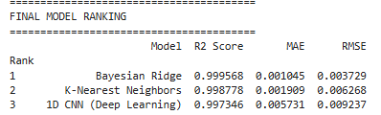
Figure 1: Algorithm Performance Ranking Table (Bayesian Ridge, K-Nearest Neighbors, and 1D CNN)
According to the performance ranking in Figure 1, the Bayesian Ridge Model has an overall R2 Score of 0.999568, which was closely followed by K-Nearest Neighbors (KNN) with a score of 0.998778, and 1D CNN with a score of 0.997346. When it comes to MAE (Mean Absolute Error), Bayesian Ridge had the least error (0.001045), indicating that it has a high ability to reduce its prediction error. KNN gave good results as well, having an MAE of 0.001909. 1D CNN had a marginally greater MAE (0.005731) and was competitive in all respects. These findings suggest that Bayesian Ridge is the best option in terms of accuracy and error reduction but KNN and 1D CNN present useful contributions with their respective advantages in the metrics of performance.
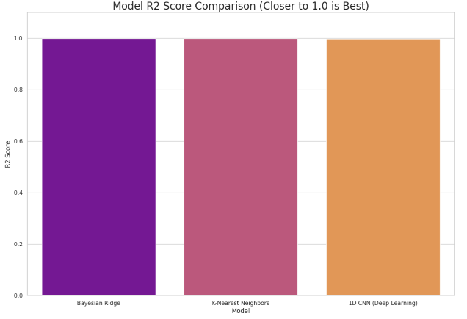
Figure 2: Performance Comparison: Bayesian Ridge, K-Nearest Neighbors, and 1D CNN
Figure 2 is a bar chart that visually compares the performance of the model in terms of the important metrics including R2 Score, MAE and RMSE. Bayesian Ridge is the best fitted to the data as demonstrated in the chart where it has the highest R2 Score. KNN is the nearest in R2 Score and its advantage is in classification tasks. The error rate of 1D CNN is a little higher, but is still competitive particularly in the identification of more complex patterns that are not easily captured by simpler models. Overall, the comparison illustrates that Bayesian Ridge is the best performer in terms of accuracy and error minimization, while KNN and 1D CNN contribute valuable insights with their own unique advantages.
GRU, Support Vector Regressor (SVR) and Gradient Boosting
Three robust algorithms Gradient Boosting, GRU (Gated Recurrent Units), and Support Vector Regressor (SVR) were adopted in the modeling phase to predict the price of cryptocurrencies. Gradient Boosting is an ensemble learning method, which develops a series of models, which rectify the mistakes of the other, hence producing a very precise model to regression tasks. GRU is a recurrent neural network (RNN) that is particularly good at modeling long-term correlations in time-series data, which is why it is a good candidate to predict cryptocurrency prices, where past prices predict future patterns. Conversely, Support Vector Regressor (SVR) is a robust regression model that operates on the principle of identifying the optimal hyperplane that most accurately describes the data, but which must be tuned carefully to achieve good results, especially when using noisy data such as cryptocurrency price changes.
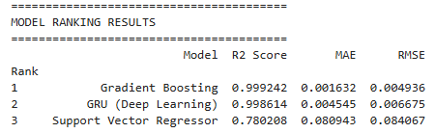
Figure 3: Model Performance Ranking Table (Gradient Boosting, GRU, and SVR)
According to the performance ranking in Figure 3, the Gradient Boosting model had the highest overall R2 Score of 0.999242, next was the GRU (Deep Learning) with 0.998614 and Support Vector Regressor (SVR) with 0.780208. Gradient Boosting has the lowest error of 0.001632 in terms of MAE (Mean Absolute Error), which indicates that it is a more accurate predictor. GRU also has a good MAE of 0.004545 and SVR had a greater error (0.080943). These findings indicate that Gradient Boosting is the most effective in the accuracy and error reduction.
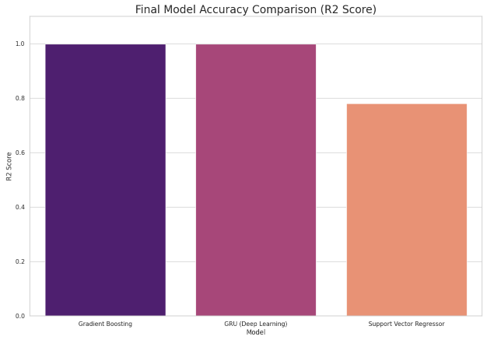
Figure 4: Performance Comparison: Gradient Boosting, GRU, and SVR
The bar chart in Figure 4 compares the R2 Score of the three models. Gradient Boosting is better than both GRU and SVR, as indicated by its better R2 Score. GRU does a good job but is slightly worse than Gradient Boosting in this forecasting exercise. Although SVR is more effective in some tasks, its performance in this context is lower compared to DNN, in particular due to the higher MAE and RMSE. Altogether, Gradient Boosting is the best of these models, as it offers the best accuracy and low error. GRU is a powerful competitor of time dependencies and SVR might need additional adjustments to be competitive with this task.
Simple RNN, AdaBoost and Decision Tree
In the modeling stage, the decision tree, Simple Recurrent Neural Network (RNN), and AdaBoost were installed to determine their price prediction capabilities in cryptocurrencies. Decision Tree model divides data into decision nodes according to the values of features thus easy to interpret as well as quick to execute, although it is likely to overfit without a sufficient pruning. Simple RNN is a kind of recurrent neural network used to capture sequential dependencies in time-series data, which comes in handy when price forecasting when past values impact future forecasts. Finally, AdaBoost, an ensemble method, was used to integrate several weak learners (usually decision trees) to form a strong model by targeting instances which are misclassified during each run.
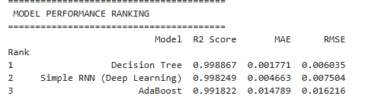
Figure 5: Model Performance Ranking Table (Decision Tree, Simple RNN, and AdaBoost)
According to the performance ranking in Figure 5, the Decision Tree model had the highest R2 Score of 0.998867, whereas Simple RNN (Deep Learning) and AdaBoost have a close R2 Score of 0.998249 and 0.991822. Decision Tree, in terms of MAE (Mean Absolute Error), scored the highest at 0.001771, which means that it can forecast prices with the lowest error. Simple RNN had the lowest MAE of 0.004663, whereas AdaBoost had the largest MAE of 0.014789. These findings indicate that the Decision Tree is the most precise and faithful model to use this task.
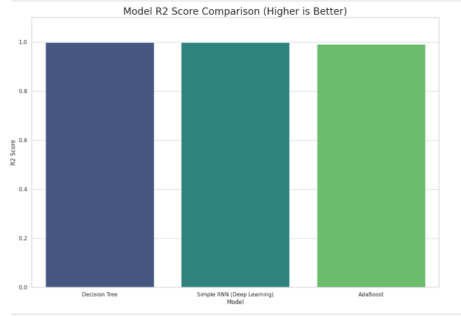
Figure 6: Performance Comparison: Decision Tree, Simple RNN, and AdaBoost
The bar chart in Figure 6 compares the R2 Score of the three models. Decision Tree is the top in performance, then Simple RNN, and AdaBoost comes in a bit behind. This diagram supports the idea that although any of the models can work well, Decision Tree is the most efficient in this situation to predict cryptocurrency prices, and Simple RNN could be used as a competitor to capture sequential trends.
Linear Regression, random forest and LSTM
Three models, including Linear Regression, Random Forest, and LSTM (Long Short-Term Memory), were tested in this stage to determine the effectiveness of the models in predicting cryptocurrency prices. Linear Regression is a very easy but effective model that is used to predict continuous values by creating a linear correlation between input variables and the target variable. Linear Regression is quick and easy to interpret, but it might not be able to cope with non-linear data. An ensemble learning algorithm, known as random Forest is applied to enhance the precision of the forecasts through the combination of various decision trees, which can be used to adjust the complex association in the data. LSTM (Deep Learning) is a particular form of recurrent neural network that is specifically tailored to work with sequential data and learn long-term dependencies, which is why it is a good fit to time-series forecasting such as cryptocurrency prices.
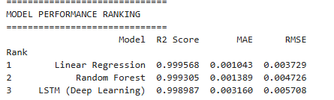
Figure 7: Model Performance Ranking Table (Linear Regression, Random Forest, and LSTM)
According to performance ranking as indicated by Figure 7, Linear Regression model had the highest R 2 Score of 0.999568, then followed by Random Forest 0.999305 and LSTM 0.998987. Linear Regression has the lowest error of 0.001043 in terms of MAE (Mean Absolute Error) indicating its accuracy in price prediction. Random Forest was equally successful, having an MAE of 0.001389 whereas LSTM had a slightly greater error of 0.003160. The results emphasize that Linear Regression and Random Forest are powerful in their performance, and LSTM remains competitive in working with sequential data.
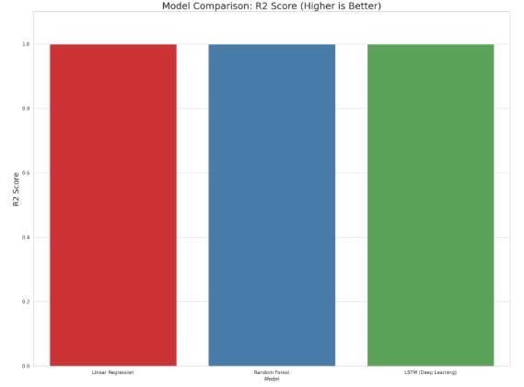
Figure 8: Model Performance Ranking Table (Linear Regression, Random Forest, and LSTM)
The bar chart in Figure 8 compares the R2 Score of the three models. Linear Regression shows a slight edge over Random Forest and LSTM in terms of R2 Score. Nevertheless, Random Forest and LSTM have superior generalization and can identify more intricate patterns in the data. This chart confirms that Linear Regression is a robust baseline model, and ensemble and deep learning, such as Random Forest and LSTM, provide extra strength to more complex forecasting problems.

